## AUTOMATION TESTING

Internship Report submitted in partial fulfillment of the requirements for the award of the degree of

##### BACHELOR OF TECHNOLOGY IN

**COMPUTER SCIENCE AND ENGINEERING**

By

**Ejumalla Saikiran**

**22R15A0514**



**Department of Computer Science and Engineering**

**Accredited by NBA**

#### Geethanjali College of Engineering and Technology

##### (UGC Autonomous)

(Affiliated to J.N.T.U.H, Approved by AICTE, New Delhi) Cheeryal (V), Keesara (M), Medchal.Dist.-501 301.

**July 2023**

# Geethanjali College of Engineering and Technology

##### (UGC Autonomous)

(Affiliated to JNTUH, Approved by AICTE, New Delhi) Cheeryal (V), Keesara(M), Medchal Dist.-501 301.

**DEPARTMENT OF COMPUTER SCIENCE AND ENGINEERING**

**Accredited by NBA**



**CERTIFICATE**

This is to certify that the Internship Report entitled **“AUTOMATION TESTING”** is a bonafide work done by **Ejumalla Sai Kiran (22R15A0514)** in partial fulfillment of the requirements of the award for the degree of Bachelor of Technology in “**Computer Science and Engineering**” from Jawaharlal Nehru Technological University, Hyderabad during the year 2023-2024.

##### 

##### HOD - CSE

**Dr. A Sree Lakshmi**

##### Professor

**Examiner**

Signature: Name: Designation:

**INTERNSHIP CERTIFICATE**

**&**

**QA Automation Engineer Certificate**

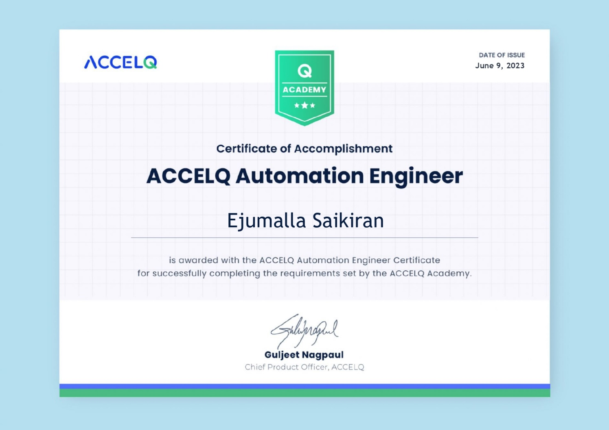

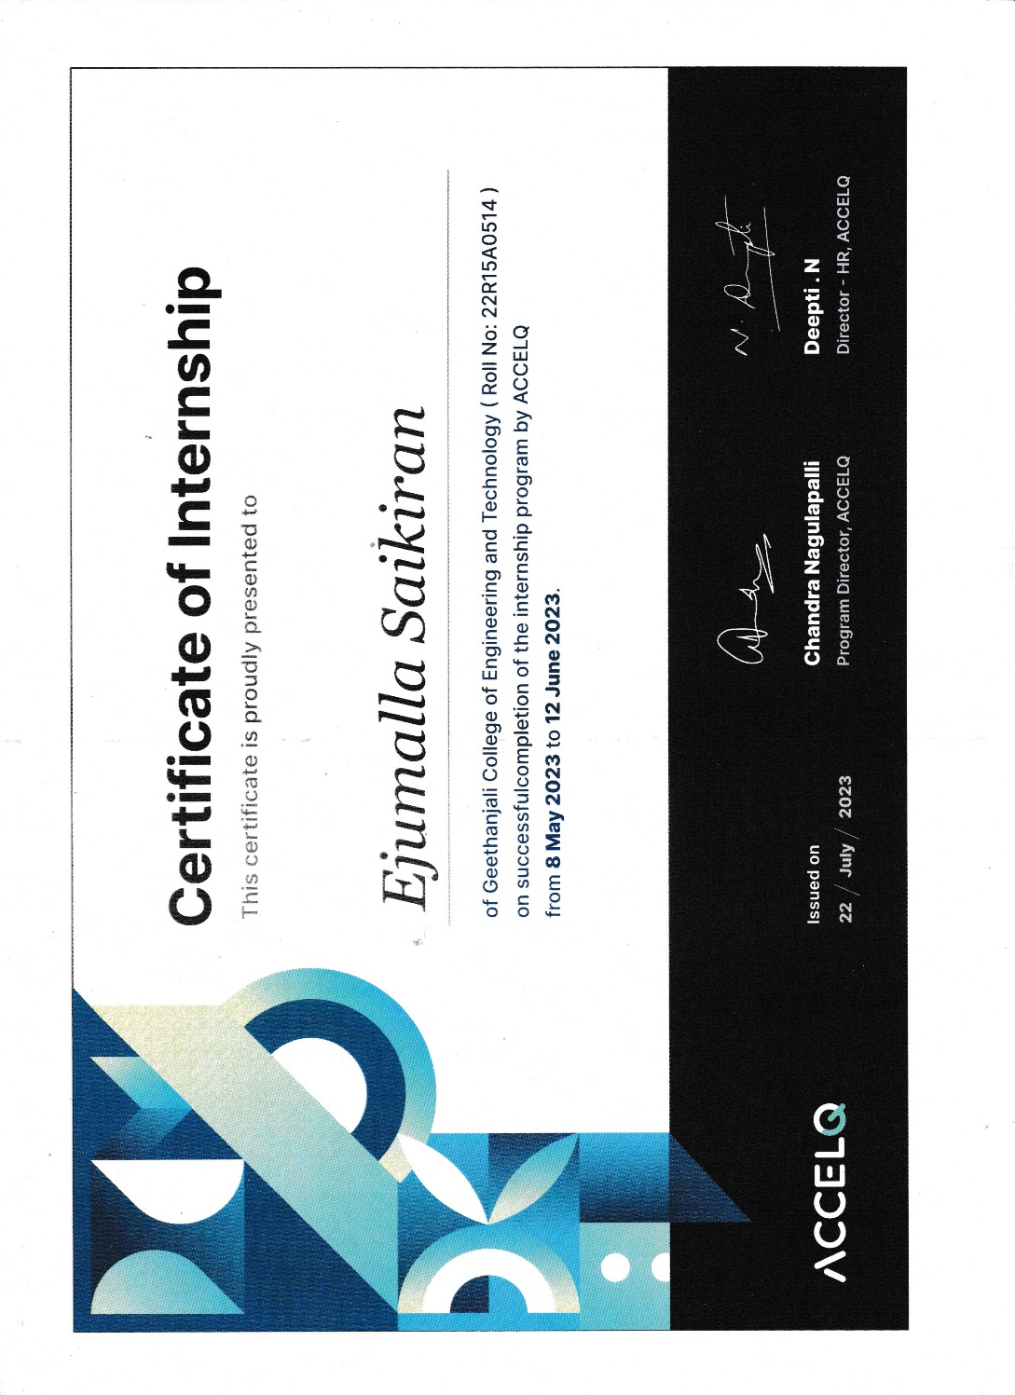

# Geethanjali College of Engineering and Technology

##### (UGC Autonomous)

(Affiliated to JNTUH Approved by AICTE, New Delhi) Cheeryal (V), Keesara(M), Medchal Dist.-501 301.

**DEPARTMENT OF COMPUTER SCIENCE AND ENGINEERING**

**Accredited by NBA**



**DECLARATION BY THE CANDIDATE**

I, **Ejumalla Saikiran**, bearing Roll No. **22R15A0514**, hereby declare that the Internship Report entitled **“Automation Testing”** is submitted in partial fulfillment of the requirements for the award of the degree of **Bachelor of Technology** in **Computer Science and Engineering**.This is a record of bonafide work carried out by me in {**ACCELQ**}and the results embodied in this internship report have not been reproduced or copied from any source. The results embodied in this Internship Report have not been submitted to any other University or Institute for the award of any other degree or diploma.

**Ejumalla Saikiran,**

**22R15A0514,**

**Department of CSE,**

**GCET**

**ACKNOWLEDGEMENT**

The work in this report is an outcome of continuous work over a period and drew intellectual support from Accelq. I would like to articulate our profound gratitude and indebtedness to Accelq who helped us in completion of training. I am thankful to Acceq training Associates for teaching me the required skills. I would like to extend my thanks to Accelq for providing me internship and doubt support. We would like to thank**, Mr. Raja Krishna Kumar, ACCELQ member** for his wonderful support and unforgettable help towards the internship.We would like to thank **Dr. A. Sree Lakshmi**, Professor & Head of the Department of Computer Science and Engineering for inspiring us to take up a project on this subject and successfully guiding us towards its completion.We would like to thank **Prof. V. Madhusudhan Rao**, Dean, School of Computer Science Engineering for providing us by means of attaining our cherished goals.We would like to thank Director **Mr .G. R. Ravinder Reddy** whose sayings and teachings have been pivotal for us in all aspects of our academics. He has stood beside us in all the difficult times, and his love has helped us to overcome all the failures and success. We express our gratitude to the institution **GEETHANJALI COLLEGE OF ENGINEERING AND TECHNOLOGY.**

**E. Saikiran,**

22R15A0514

**Introduction about Internship Organization**

Accelq is the only cloud-based continuous testing platform that seamlessly automates API and web testing without writing a single line of code. Automation is integrated with manual testing process under one umbrella, making it possible for agile teams to manage QA life cycle effectively. It teams of all sizes use accelq to accelerate their testing by adapting lifecycle automation approach that spans test design, planning, test generation and execution. Accelq customers typically save over 70% of the cost involved in the change and maintenance efforts in testing, addressing one of the major pain points in the industry. Accelq makes with an AI & ML powered core. Design and User-experience is the heart of Accel’s continuous innovation approach, Which allows stakeholders with varied levels of technical backgrounds to effectively collaborate for Quality.

**Training Schedule**

Training start Date: 08-05-2023

E-Learning Content and pre-requisite Completion: 09-06-2023

Internship Program and project: 08-05-2023 to 12-06-2023

### TABLE OF CONTENTS

|  |  |  |
| --- | --- | --- |
| **S.No.** | **Contents** | **Page No** |
|  | **Abstract** | **i** |
|  | **List of Figures** | **ii** |
|  | **List of Screenshots** | **iii** |
| **1** | **Introduction** | **1-3** |
| **2** | **Related work/ Technologies used** | 4-23 |
| **3** | **Work done/ Observation/ Duties performed** | 24-26 |
| **4** | **Learning after Internship** | 27 |
| **5** | **Summary / Conclusion** | 28 |
| **6** | **Bibliography** | 29 |

**ABSTRACT**

In our tech world at present scenario all computer genius, scientists and engineers are hardly trying to achieve some thing new that reduces the human efforts. In general humans may do mistakes while handling big data that will leads to big problem. If we assign that human work to the software that is implemented by AI the chances of doing mistakes will be reduced. Hence, to achieve that the ACCELQ is trying it’s best to overcome that scenario. ACCELQ makes this possible with an AI & ML powered core. Design and User-experience is at the heart of ACCELQ's continuous innovation approach, which allows stakeholders with varied levels of technical backgrounds to effectively collaborate for Quality. ACCELQ customers typically save over 70% of the cost involved in the change & maintenance efforts in testing, addressing one of the major pain points in the industry.

**LIST OF FIGURES**

|  |  |  |  |
| --- | --- | --- | --- |
| 1 | 1.2.1 | Life Cycle of AccelQ |  |
| 2 | 1.2.2 | Salient Components of AccelQ |  |
| 3 | 2.1 | Hardware & Software components |  |
| 4 | 2.1.1 | Scenario |  |
| 5 | 2.1.2 | Side Navigation Bar |  |
| 6 | 2.1.3 | Tabs Area |  |
| 7 | 2.1.4 | Global Search, Run Button, New Entity Creation |  |
| 8 | 2.1.5 | Help Center |  |
| 9 | 2.1.6 | Project Config Area &User Profile |  |
| 10 | 2.1.7 | Test Asset View |  |
| 11 | 2.2.1 | Universe |  |
| 12 | 2.2.2 | Filtering the Universe |  |
| 13 | 2.3.1 | Navigator |  |
| 14 | 2.3.2 | Resources |  |
| 15 | 2.5.1 | Results |  |
| 16 | 2.5.2 | The test details screen |  |
| 17 | 2.6.1 | Project Configuration |  |
| 18 | 2.7.1 | User Profile Information |  |
| 19 | 2.8.1 | Entities |  |
| 20 | 2.9.1 | Project Information |  |
| 21 | 2.10.1 | Activity |  |
| 22 | 2.11.1 | Selecting Test Asset View |  |

|  |  |  |  |
| --- | --- | --- | --- |
| **LIST OF SCREEN SHOTS** | | | |
| **S. No** | **Fig. No** | **Title of Figure** | **Page. No** |
| 1 | 3.1 | Test Steps | 25 |
| 2 | 3.2 | Verifying all menu Items | 26 |
| 3 | 3.3 | Data List | 27 |
| 4 | 3.4 | Verify Departments | 28 |

1. **INTRODUCTION**

**1.1 ACCELQ**

ACCELQ is a cloud-based, continuous testing platform for functional and API testing needs. ACCELQ is offered both on SAAS and On-Premise models.

**1.2 LIFE CYCLE**

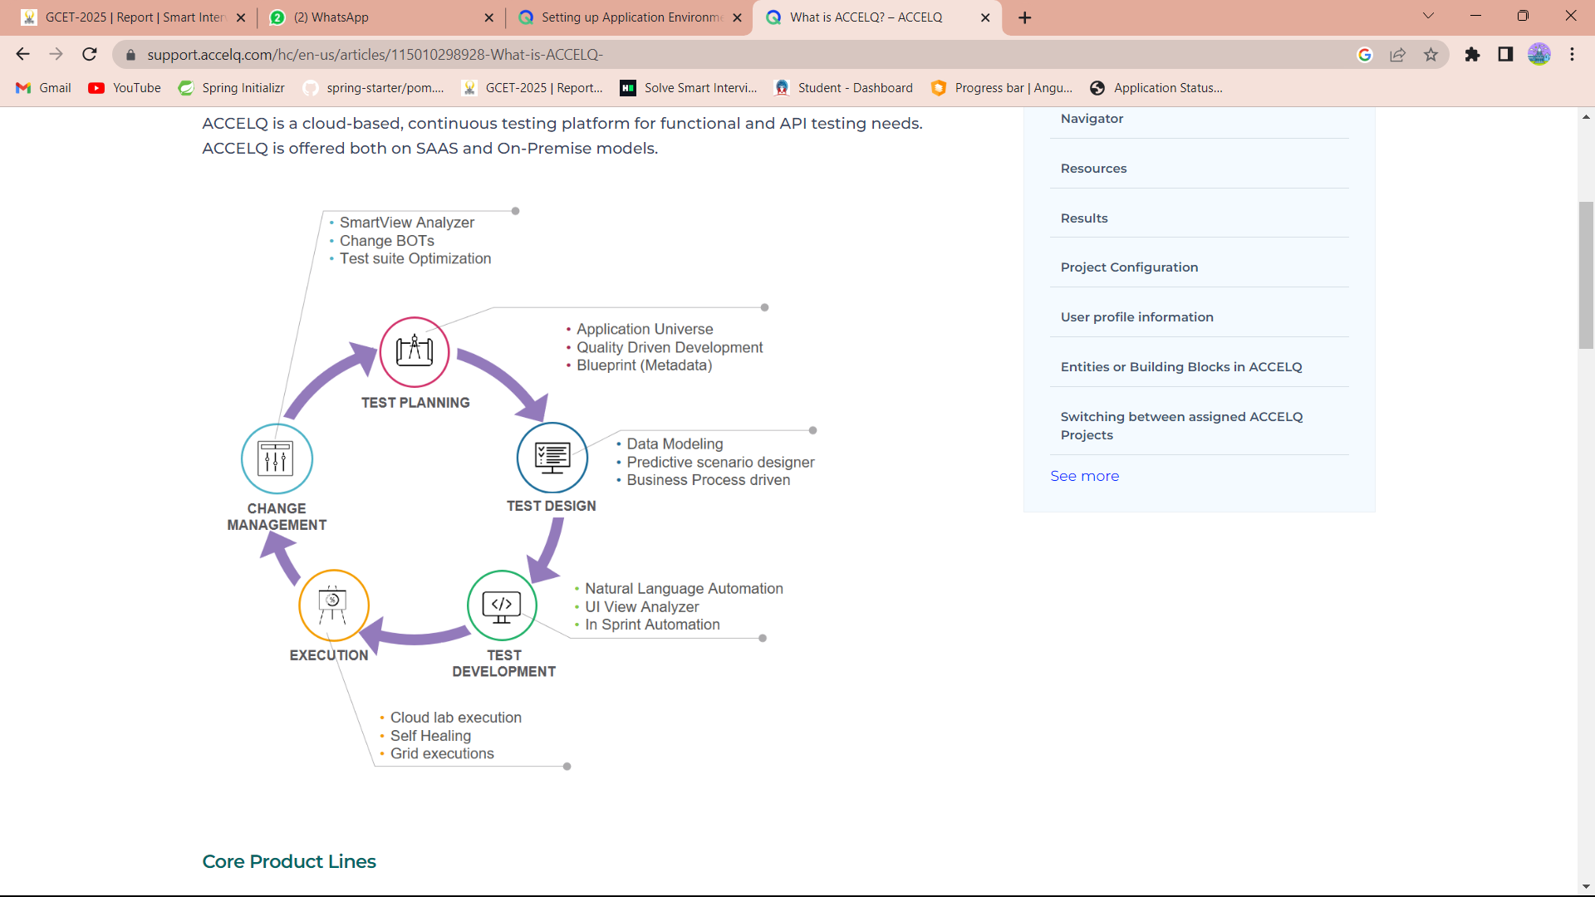

**Fig 1.2.1 Life Cycle of AccelQ**

#### Core Product Lines

In fig 1.2.1 ACCELQ delivers next-gen aligned test management and automation capabilities with the following product offerings:

**Automate** **Web** is a comprehensive test automation solution built on a codeless architecture for Web, desktop and mainframes automation. ACCELQ adapts the concept of Lifecycle Automation, where automation is fully integrated with the test lifecycle rather than being a technical silo. All aspects of test cycle such as test design, development, execution and analysis are automated.

**Automate API** is an automated solution exclusively designed for API testing. ACCELQ brings Regression level maturity to API testing, and allows seamless integration between API and functional testing. You can develop an automated test flow, that goes end-to-end across all layers of your application stack. This product also includes extensive support for backend and middleware testing.

**Automate Mobile** is an automated solution for mobile application testing. It supports testing across mobile devices and OS, completely in a codeless approach. A portable element design allows you to run exact same tests on both iOS and Android.

**ACCELQ Manual** is a complete end-to-end manual testing and test management solution built on the principles of a modular approach to Manual testing and seamless integration with eco-system of tools.

[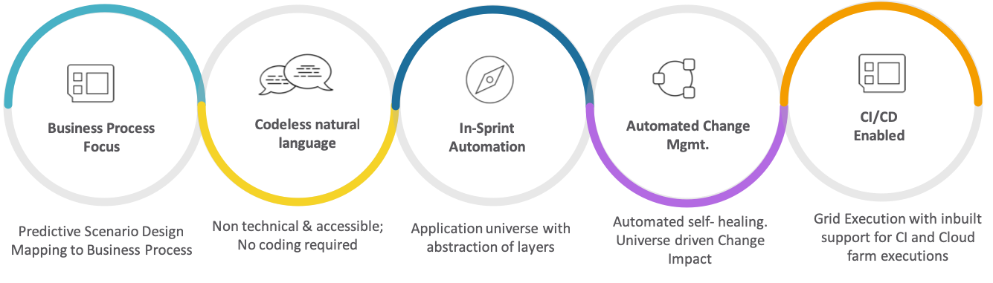](https://support.accelq.com/hc/article_attachments/360026818451/accelqIntro.png)

#### Fig 1.2.2 Salient Components of ACCELQ

#### Business Process Driven

In ACCELQ, Business Process is at the center of an automation asset. You start from a Business Process and design your test scenario. As you build detailed logic for the test scenario, business process continues to be the driver and never becomes an artifact.

Testing is managed and prioritized with rich visual representations. Central to this, is the idea of Universe, which captures the application interactions and API calls to serve various testing and analysis needs.

#### Test logic in Natural Language

Through an innovative natural language approach, ACCELQ delivers a complete automation solution without having to write any frameworks or learn a programming syntax. All test assets are accessible to the entire team without any technical barriers.

Complex test logic can be developed in English abstraction with a browser-based logic editor.

#### In-Sprint automation is a reality with ACCELQ

The abstraction concept allows in-sprint automation by providing the ability to develop full-blown automation test assets even when the application-under-test is still under development. When your app UI is ready, you can reconcile it with the application.

Self-healing capabilities ensure reliable test execution in case of unforeseen changes to application UI or environment.

#### Native integration with CI/CD cycle

With plugins readily available for most major CI/CD tools, ACCELQ brings functional automation into the CI/CD cycle. Execute automation suites without any setup requirement.

#### Support for a broad spectrum of applications

Support for functional test automation includes all browser-based technologies including Bootstrap, GWT, Angular, etc. The latest front-end frameworks are supported out of the box.

Support for API and middleware testing extends into testing for REST services, SOAP services, JMS, Service Bus, Database, etc. with the same level of ease and intuition as functional test automation.

Additionally, ACCELQ supports full-blown automation of Terminal Emulator (green screen) windows.

Mobile test automation is comprehensive against multiple OS and Device combinations.

#### Core Product Lines

ACCELQ delivers next-gen aligned test management and automation capabilities with the following product offerings:

**Automate** **Web** is a comprehensive test automation solution built on a codeless architecture for Web, desktop and mainframes automation. ACCELQ adapts the concept of Lifecycle Automation, where automation is fully integrated with the test lifecycle rather than being a technical silo. All aspects of test cycle such as test design, development, execution and analysis are automated.

**Automate API** is an automated solution exclusively designed for API testing. ACCELQ brings Regression level maturity to API testing, and allows seamless integration between API and functional testing. You can develop an automated test flow, that goes end-to-end across all layers of your application stack. This product also includes extensive support for backend and middleware testing.

**Automate Mobile** is an automated solution for mobile application testing. It supports testing across mobile devices and OS, completely in a codeless approach. A portable element design allows you to run exact same tests on both iOS and Android.

**ACCELQ Manual** is a complete end-to-end manual testing and test management solution built on the principles of a modular approach to Manual testing and seamless integration with eco-system of tools.

### TECHNOLOGIES USED

### The ACCELQ came with a software tool called ACCELQ. It is the technology used for testing purpose.

### HARDWARE / SOFTWARE REQUIREMENT

AccelQ local agent can run a windows desktop, a Linux machine or a MacBook. Note that the agent only serves as a machine from where the browser will invoke to run the test. It is not necessary to bring a server class configuration. Here are some configuration parameters

### Quad-core processor

### 8 GB RAM

### 250 GB Hard-Drive

* JDK 11. Make sure to have Java Development Kit, not just the run time/JRE. It is necessary to run the test cases in accelq platform.
* Windows, Linux or Mac Operating System. For Linux machines, make sure it has GUI or desktop environment enabled.

### APPLLICATON LAYOUT

### In fig 2.1.1 the ACCELQ application UI layout is divided into 5 parts:

1. Side Navigation Bar
2. Tabs Area
3. Global Toolbar Area
4. Help Center
5. Project Config Area & User Profile

[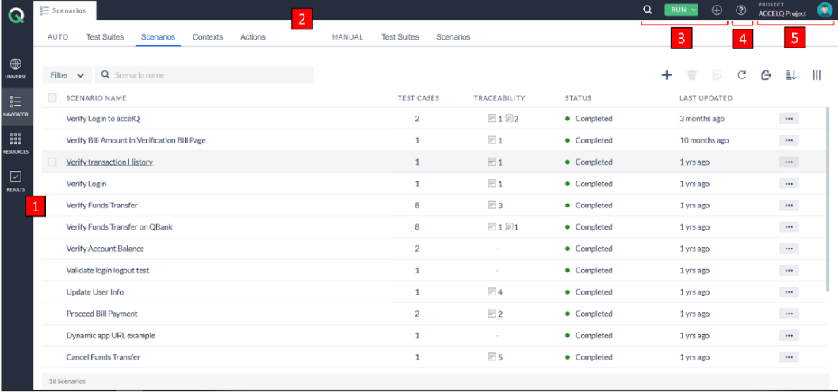](https://support.accelq.com/hc/article_attachments/6939439838221/Application_Layout_LATEST3.png)

Fig 2.1.1 Scenario

**2.1.1 Side Navigation bar**

In fig 2.1.2 the Side Navigation bar groups the application into logical sections and make it easy for the user to navigate from one section to another easily and effectively. The Navigation bar consists of Universe, Navigator, Resources, and Results.

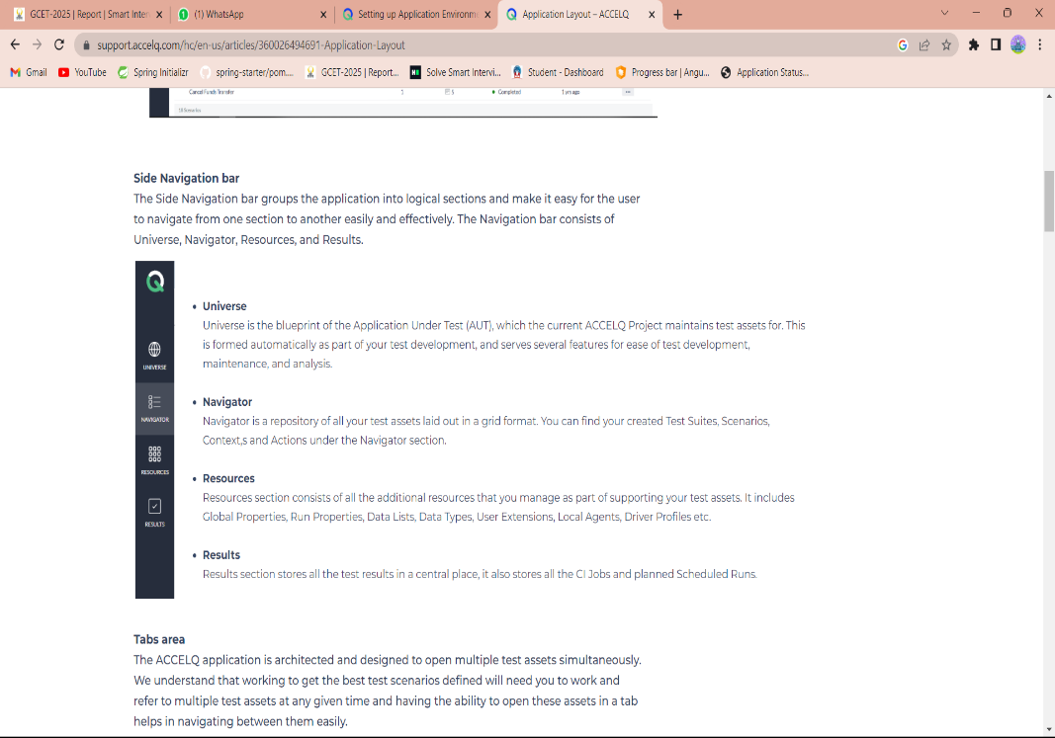

Fig 2.1.2 Side Navigation Bar

**2.1.2 Tabs area**

The ACCELQ application is architected and designed to open multiple test assets simultaneously. We understand that working to get the best test scenarios defined will need you to work and refer to multiple test assets at any given time and having the ability to open these assets in a tab helps in navigating between them easily.

[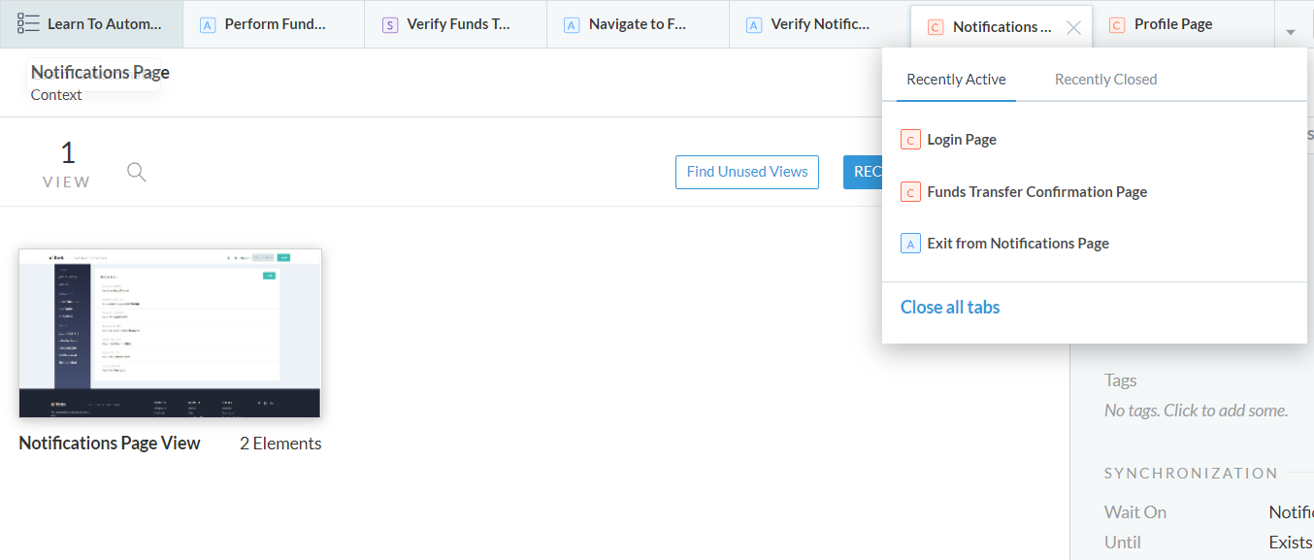](https://support.accelq.com/hc/article_attachments/4412148628749/Tabs_area_NEW.PNG)

Fig 2.1.3 Tabs area

There are 2 kinds of tabs in the ACCELQ Application. The first tab is a fixed tab and cannot be removed, the content of this fixed tab depends on the section you are in. For example, when you click on the Navigator section from the sidebar the fixed tab will show the Navigator grid.

The other tabs that get opened when you click on the asset name can be closed if needed. In general, depending on your screen resolution and size you should be able to see 5-6 tabs on the tab area, the overflowing tabs go under the list of the tab which can be accessed from the arrow icon next to the last tab.

**2.1.3 Global Toolbar area**

The global toolbar area consists of actions that can be needed at any point in time and should have easy access no matter where you are in the application. The toolbar consists of Global Search, New Entity creation, Activity Log, and Run button.

[](https://support.accelq.com/hc/article_attachments/6933247967885/Global_Toolbar_LATEST.png)

Fig 2.1.4 Global Search, Run Button, New Entity Creation

* **Global Search**

Global Search is an extremely powerful feature in the ACCELQ application which helps you to quickly jump to your desired asset. You can search for any test asset. To make the finding easier the search result drop-down is categorized as per the asset type.

* **Run button**

A global Run Button enables you to execute a Scenario or a Test Suite. You can also schedule a CI job or schedule a Run from here.

* **New Entity Creation**

New asset creation is just a click away. No matter where you are in the application, click on the New Entity icon and select the asset type you would like to create.

**2.1.4 Help Center**

[](https://support.accelq.com/hc/article_attachments/6933354544909/Help_Centre_Icon_LATEST.png)

Fig 2.1.5 Help Center

The help center in ACCELQ is context-aware and will show you the help articles based on which location/ section/ asset you are currently viewing. Help Center is much more than just a repository of help articles, you will find a lot of very interesting content under the help center.

[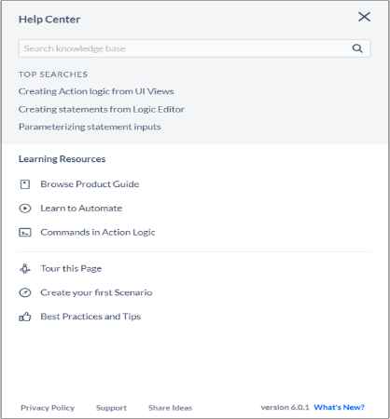](https://support.accelq.com/hc/article_attachments/14139311015181)

Fig 2.1.5 Help Center

* **Search knowledge base**

To search for a help article just type the keywords on the search box at the top of the help center.

* **Learning Resources**

Learning Resources is an extremely intuitive and powerful place for you to check out the Product Guide, get articles that help you Learn to Automate, explore the different commands in Action Logic, etc.

* **Other Options**

The Help Center also offers other options like taking a tour of the current page, a guide to help you create your first Scenario, and getting insights on the Best Practices and Tips.

* **Support**

There will be times when you would like to directly reach out to us and talk to us regarding the issue you are facing with the ACCELQ application, and we want you to be able to do that straight from the application.

* **Share Ideas**

We know you would like to share your thoughts and ideas on how we can make ACCELQ better and want to make the process of sharing your thoughts and ideas as easy as possible.

* **Current version & What’s New**

Here you can see the current version of the application and the “What’s New” section gives you the option of exploring the exciting new features of the current Release.

**2.1.5 Project Config Area & User Profile**

[](https://support.accelq.com/hc/article_attachments/6933286890253/Project_Config___User_Profile_LATEST.png)

[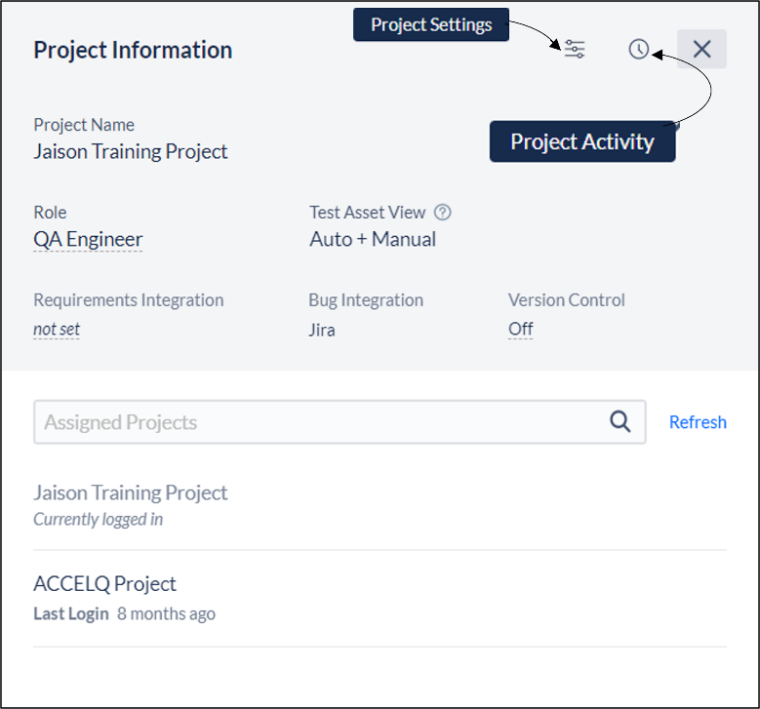](https://support.accelq.com/hc/article_attachments/14139330346893)

Fig 2.1.6 **Project Config Area & User Profile**

**Project Information**

The Project Information section consists of Project Information like the current Project Name, Role, Test Asset View, Project Activity, Integrations, Version Control, and other such project-related information including the list of all assigned projects.

**Test Asset View**

ACCELQ supports both manual and automated testing under one platform. Both these test assets are managed side by side bringing the unification and fluidity that is extremely important in an agileenvironment.

When you are assigned a Unified subscription, you may choose to select a Test Asset View for each project depending on what your main focus area is. If for a particular project, you are primarily functioning in manual testing mode, you can set up a Manual View. Similarly, you can set up an Automation-onlyView.

To change your current Test Asset View, click on the text below the ‘Test Asset View’ title that reads the name of the current view.

[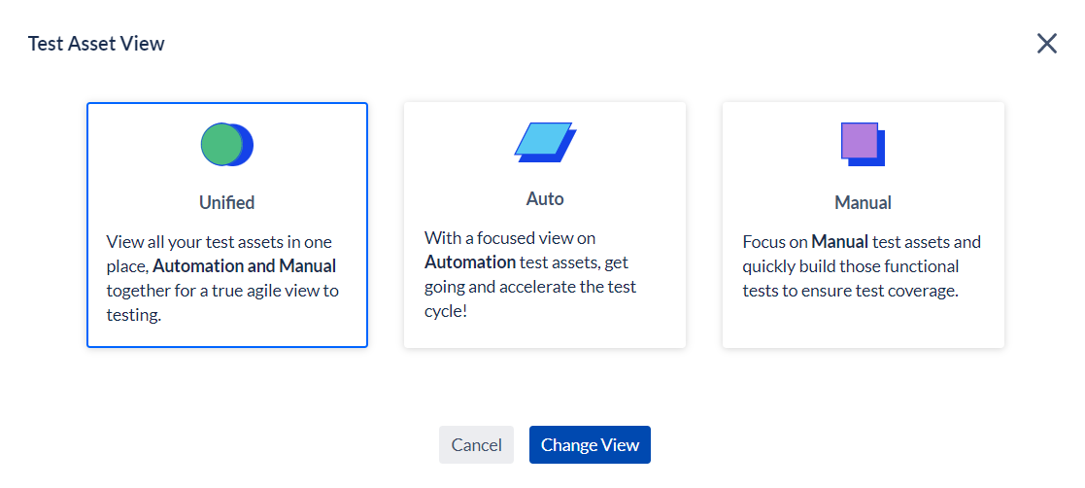](https://support.accelq.com/hc/article_attachments/14588917931661)

Fig 2.1.7 **Test Asset View**

In the resulting popover, select the desired view. This will become your default view every time you log in to this project and each project may have a different view preference.  
When you are working in Manual View, all the automation-specific entities are hidden in the project. Similarly, when operating in the Automation View, manual assets are hidden. When you are working in Unified View, explicit marking is displayed differentiating Manual and Automation assets.

**Project Settings**

The Project Settings consists of all the administration-level settings. You will be able to access these settings depending on the role you have been assigned. Only Project Admin and Tenant Admin have access to edit/modify these settings.

You can also manage project-related settings, like Custom fields, App Environments, User Setup, etc. You can set up your integration channel for defects and Requirements. You can also manage Projects and Users.

**Project Activity**

The project activity log lists the project-level activity in chronological order. Detailed change history can be tracked by opening the test asset, while this log shows high-level updates on entities.

**UserProfile**  
 User Account card shows the Name / ID of the user and the type of license that is assigned. It also shows details related to Auth properties like API Key, Project Code, and Tenant Code.  
Options to Edit Profile, Change Password, and Sign out are also available on this card.

[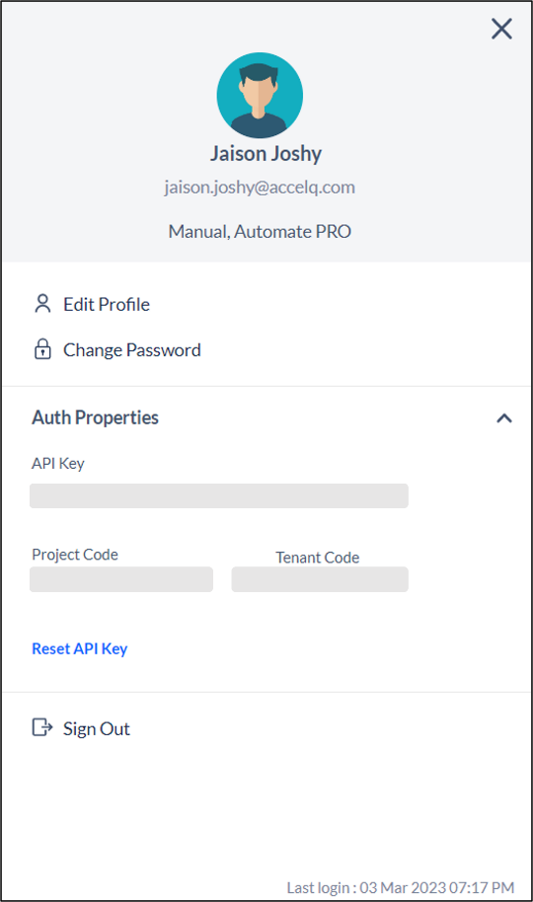](https://support.accelq.com/hc/article_attachments/14139314677645)

Fig 2.1.8 User Profile

**Work Area**

This is the area where most of the work will happen and depending on which section in the application and/or asset tab you are in the work area will change accordingly.

2.2 UNIVERSE

[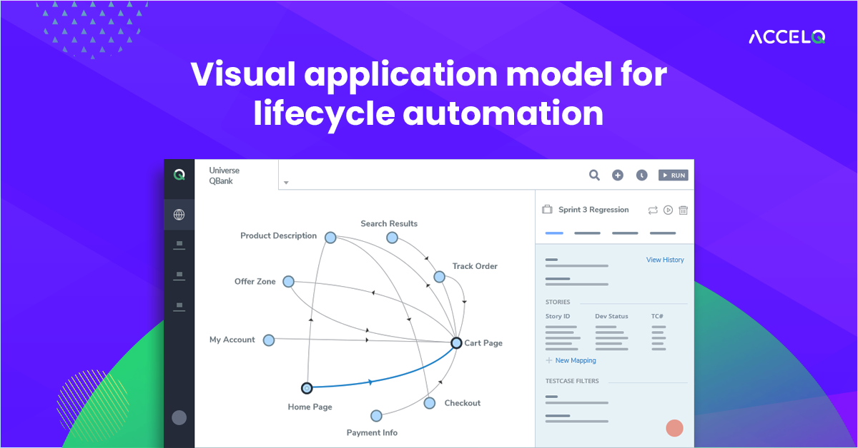](https://support.accelq.com/hc/article_attachments/4411763903629/MicrosoftTeams-image__84_.png)

Fig 2.2.1 Universe

The application universe is a graphical blueprint of your application under test (AUT). It shows a visual mapping and relation of the application assets and their interactions in between.

The Universe is divided horizontally into 2 sections: a) **Map view** and, b) **Sidebar**.

The Map view area shows the blueprint of your AUT where the circle dots denotes the contexts in your application and the lines connecting them are actions which makes it possible to traverse from one context to another in your AUT.

The Sidebar consists of the list of all the assets present in the AUT, like the Scenarios, Contexts, and Actions.1.

[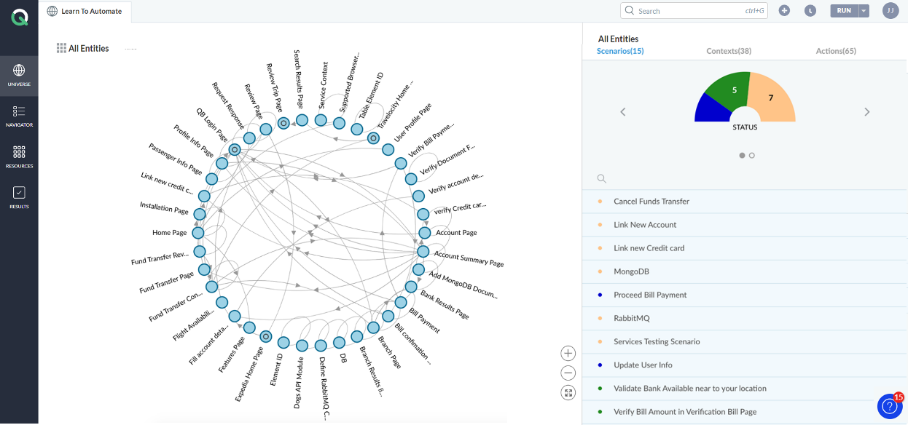](https://support.accelq.com/hc/article_attachments/4412232935949/Universe_NEW.png)

Fig 2.2.1 Universe

**Filtering the Universe**

You can filter the universe to view a particular subset of the whole AUT. There are a variety of filter options to choose from. Click on the nine-box icon on the top left of the Universe to view different filter options.

[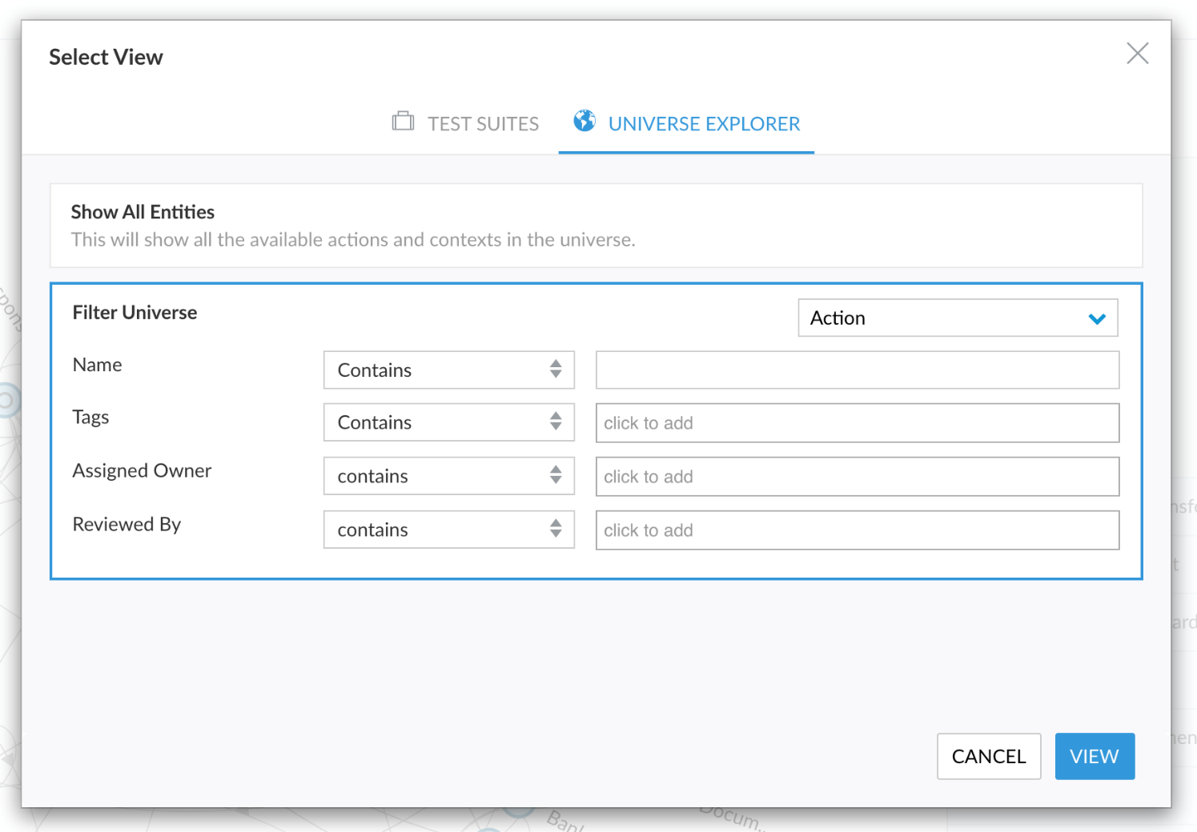](https://support.accelq.com/hc/article_attachments/360025747451/Screen_Shot_2019-04-08_at_6.11.23_PM.png)

Fig 2.2.2 Filtering the Uiniverse

### 

### 2.3 NAVIGATOR

Navigator is a repository of all your test assets laid out in a grid format. You can find your created Test Suites, Scenarios, Contexts and Actions under the Navigator section.  
  
You can filter, search or sort the asset grid. You can also add or delete new assets. Clicking on the asset name will open that asset in a new tab.

[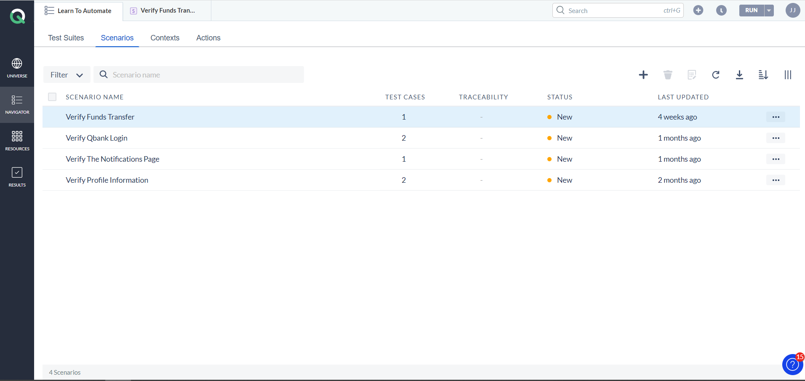](https://support.accelq.com/hc/article_attachments/4412233325325/Navigator_New.PNG)

Fig 2.3.1 Navigator

### 2.4 RESOURCES

The Resources section consist of all the additional resources you will need to run the test. It includes Global Properties, Run Properties, Data Lists, Data Types, User Extensions, Local Agents and Driver Profiles.

[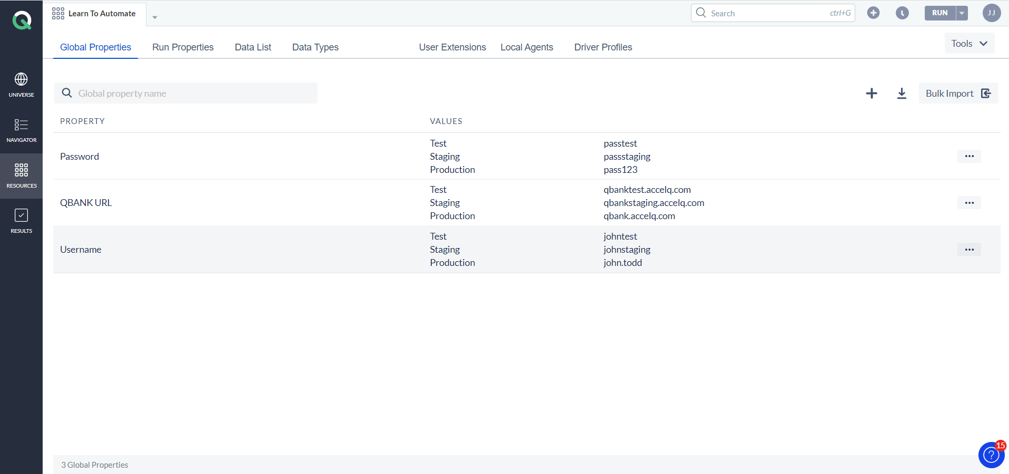](https://support.accelq.com/hc/article_attachments/4412475562253/Resources_New.PNG)

Fig 2.3.2 Resources

**Global Properties**

Global Properties are defined at project level in ACCELQ. These are used for managing parameters that are applicable at the application level such as your application URL. Values for these parameters could change from time to time (as in the URL or port number may change), but not variable at action, scenario, or test case level.

**Run Properties**

Run Properties are defined at the project level. When you define a Run Property, you just define the specification. Value is provided when a test is running (in the Run modal).

**Data List**

Data Lists define lists of standard values applicable to the Test Application. An Action Parameter can be supplied with values from defined Data Lists. Scenario Test Case Generator produces permutations to cover all the values defined for the Data List.

**Data Types**

Data Type represents a domain specific data item which has a defined classification structure. You can create the structure and manage instance values centrally in a data type.

**User Extensions**

User Extensions provide an ability to extend the standard command library set available in ACCELQ. Based on your specific need, you may upload multiple libraries. Once the library is imported, all the extension commands become available in the Action logic editor just like standard ACCELQ commands. User extension is just like any standard java source file with some ACCELQ specific annotations expected to be incorporated.

**Local Agents**

ACCELQ Local Agents allows you to run tests locally inside your firewall, while the test assets are still managed centrally either on the cloud or on your on-premise server. If you are using ACCELQ cloud subscription, this agent allows secure access to the Application Under Test (AUT). This facilitates execution of tests on systems that are otherwise not exposed outside your network, while at the same time, not requiring opening ports for such applications. It is also possible to verify against in-network resources such as a database, filesystem, etc. as required in your test logic.

**Driver Profiles**

Driver Profiles are used to define custom driver configurations for Web or Mobile apps. These configurations allow controlling browser startup behavior such as resolution, incognito etc. or device startup parameters. You can configure multiple Web Driver profiles and select one during test execution.

### 2.5 RESULTS

The Results section stores all the test results in a central place. It also stores all the CI Jobs and planned Scheduled Runs. You can search through the results and also purge the old results to effectively manage the storage. Clicking on a result will open the result details in a new tab.

[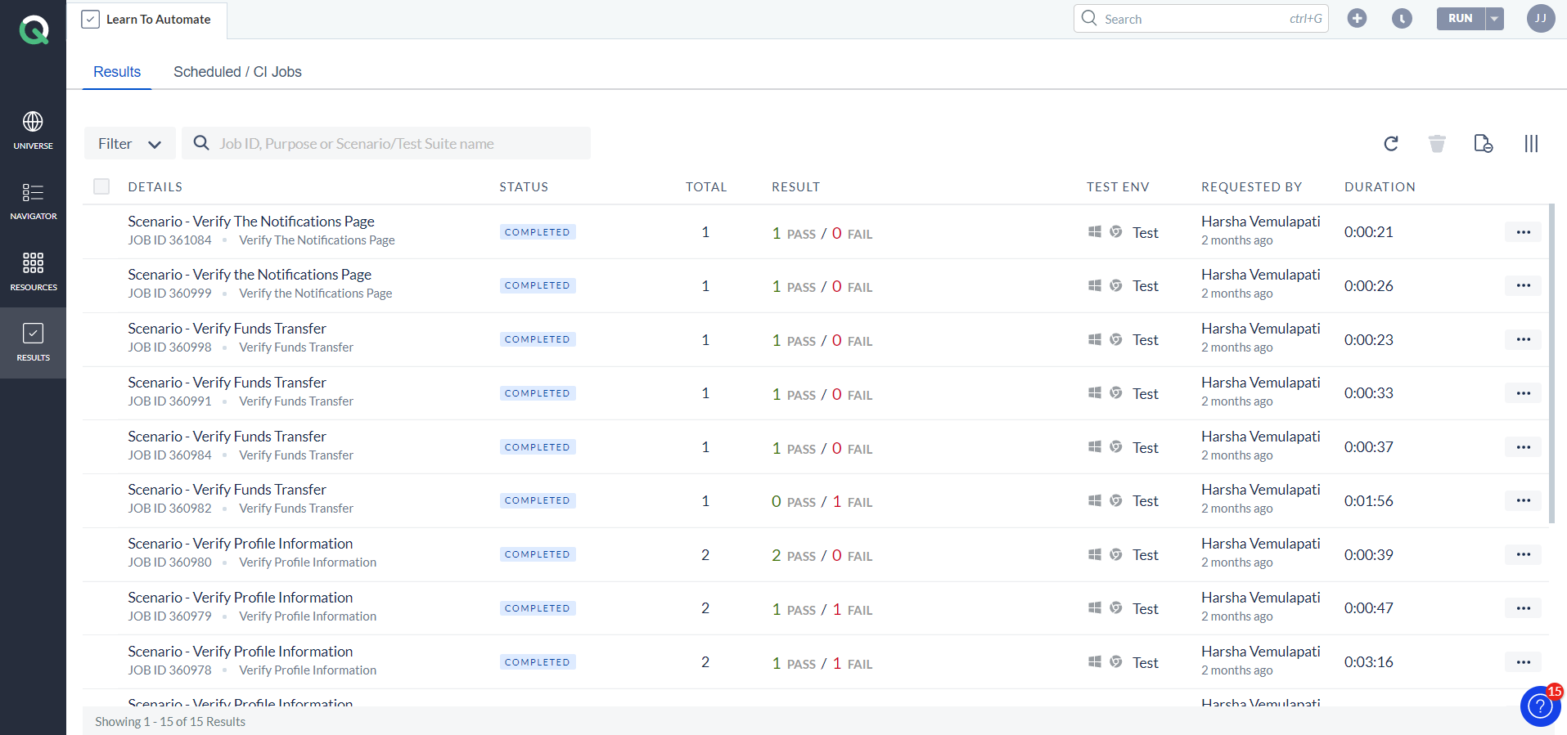](https://support.accelq.com/hc/article_attachments/4415347307789/results_grid_NEW.png)

Fig 2.5.1 Results

[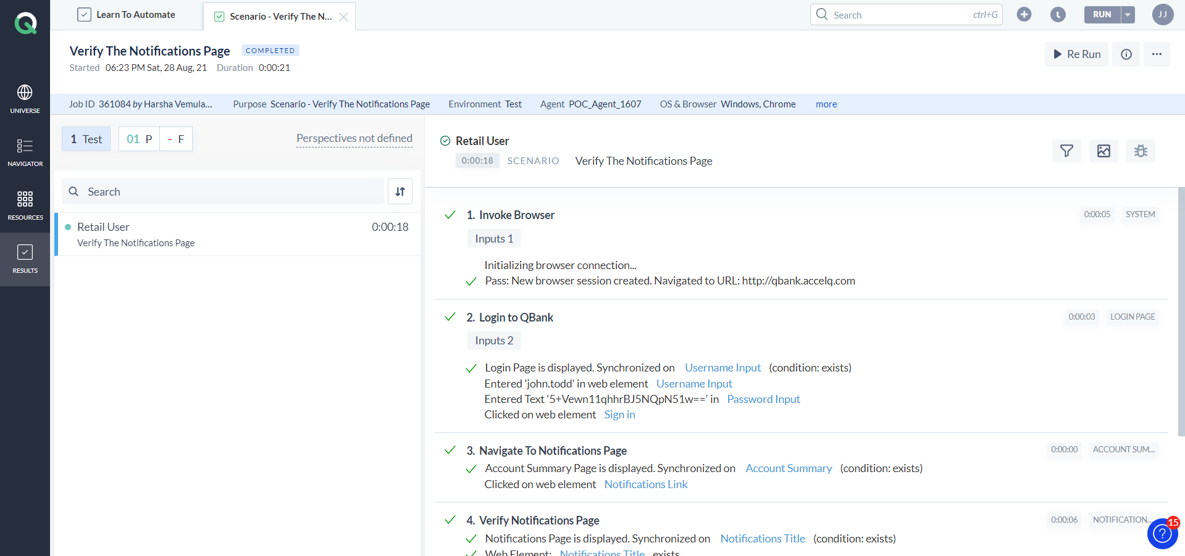](https://support.accelq.com/hc/article_attachments/4415332780813/Test_Detail_NEW.png)

Fig 2.5.2 The Test Details Screen

The Test results in ACCELQ give the user a variety of ways to slice and dice the result information using perspectives. Makes it actionable for a user by allowing it to create a bug directly from the result and if needed re-run the test fully or partially again.

You can also Re-run the test and also export, email or delete the test report.

**2.6 PROJECT CONFIGURATION**

The Project Configuration section consist of all the administration level settings specific to a given Project. You will be able to access these settings depending on the role you have been assigned. Only Project Admin and Tenant Admin have access to edit/modify these settings.

[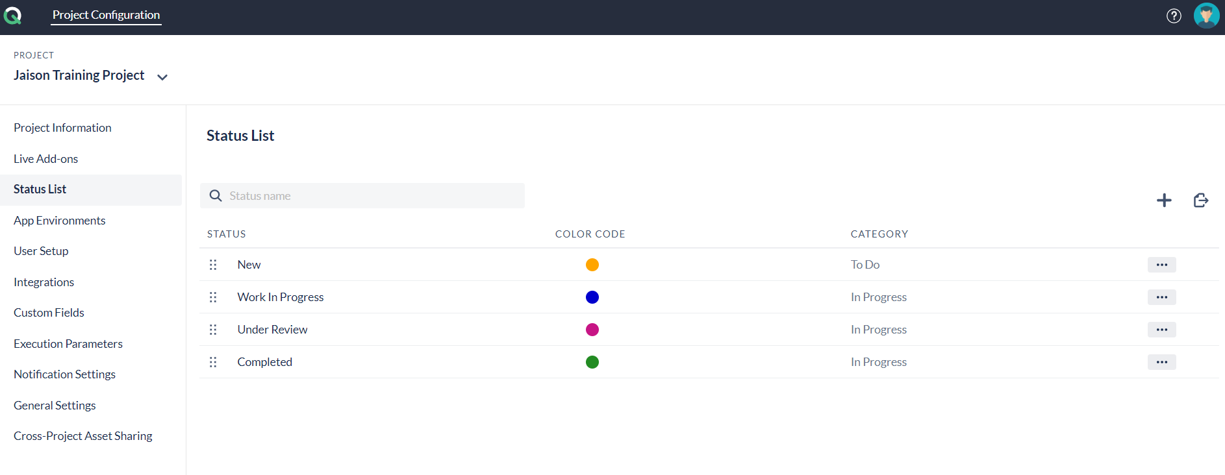](https://support.accelq.com/hc/article_attachments/14171701156237)

Fig 2.6.1 Project Configuraton

**Project Information**

Project Information shows the details of the Project like Project name, Project Type, creation date, number of users, description, branching information, etc.

**Live Add-ons**

Live Add-ons provide platform-specific test design and development components that help accelerate automation for packaged applications. Powered by the ACCELQ Live platform technology, these assets are fully managed and kept up-to-date with the vendor's Release schedule.

**Status List**

Every entity in ACCELQ carries a Status field which is configurable. under Project Configuration. The Project Administrator can set up a list of values for Statuses and order them according to the sequence they need to be presented.

**App Environment**

ACCELQ supports the concept of Application Environments, to seamlessly handle application and data variations between multiple environments such as QA, PROD, UAT, etc. This allows a clean abstraction of environment-related variations for easier management.

**User Setup**

Users in ACCELQ are managed at Tenant level. Once a user account is created, it can be assigned to one or more projects under the Tenant. A new user can be created by the Tenant Admin and can be assigned to various projects by the Project Admin.

**Integrations**

Integrations are the external applications/systems with which you would like to integrate ACCELQ for Functional traceability and Bug tracking. Currently, ACCELQ supports Defect Integration and Requirement Integration with Jira, TFS/Azure, Rally.

**Custom Fields**

Custom Fields allow metadata-based tagging for various entities to support downstream filtering and analysis requirements. You can create custom fields of different types and assign to one or more entities (Scenario, Test Case, Action, Context, Data type).

**Execution Parameters**

Execution Parameters allow you to configure your test runs, to enable analysis on results and enhanced test management. Execution Parameter list is configurable at a Project level, so that each project can define the appropriate set of Execution Parameters.

**Notification Settings**

Notification Settings allows you to setup integrations with various platforms (like Email, Slack, Microsoft Teams) to notify test execution and results.

**General Settings**  
 General Settings allows enabling/disabling various functionalities like:

* Iframe free-form search in element.
* Version Control.

Require Project Admin Privilege to purge results etc.

**Cross-Project Asset Sharing**

Cross-Project asset sharing allows Projects to make use of published Actions from other Projects in the Tenant.

**2.7 USER PROFILE INFORMATION**

User profile information is available from the top-nav in ACCELQ. Simply click on your profile icon to access this information.

The following functionalities/information is available in the Profile card:

* Edit name and profile picture.
* View the current subscription tier and licensed products.
* Edit Profile.
* Change Password.
* Authentication properties to be used for Local Agent and external API calls.
* Sign Out.
* Last logged-in date and time.

[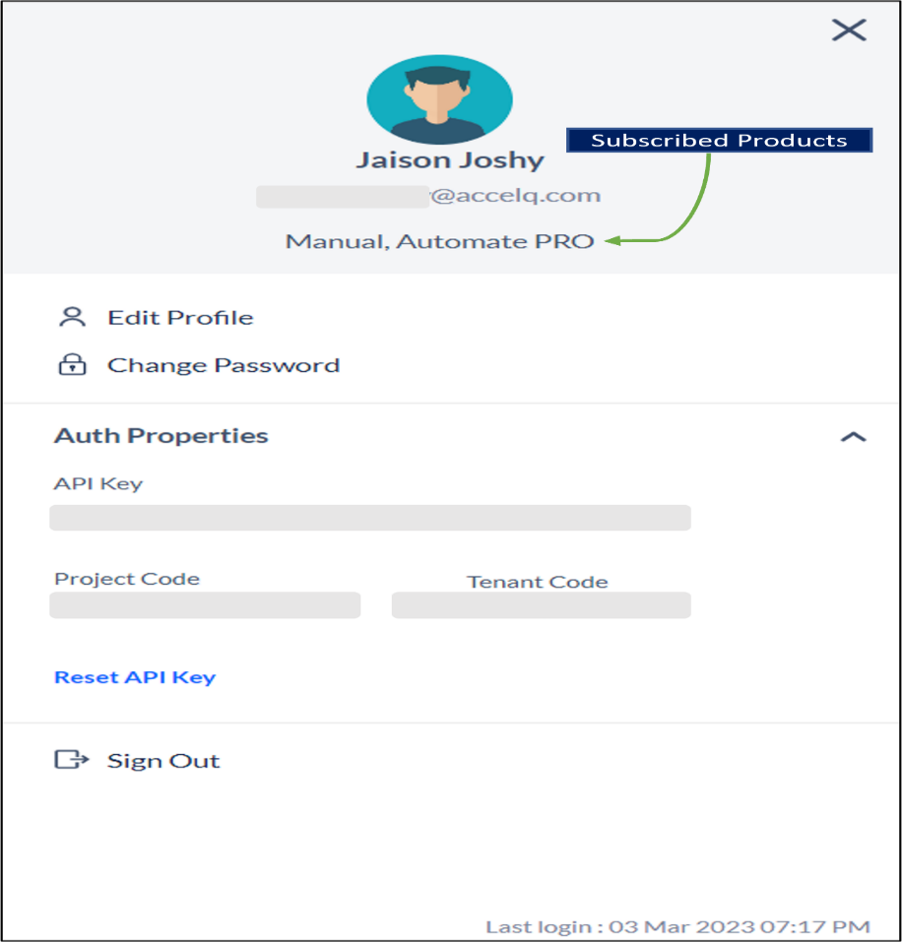](https://support.accelq.com/hc/article_attachments/14171852943757)

Fig 2.7.1 User Profile Information

**2.8 ENTITIES OR BUILDING BLOCKS OF ACCELQ**

ACCELQ creates and manages test assets in a well-structured, modular fashion with an objective to create a sustainable test automation suite. Various entities serve as building blocks and interact with each other providing a level of abstraction necessary to create a maintainable test asset.

Following diagram identifies important entities in accelQ and how they are related to each other. This article provides a brief definition of important components in this diagram. Further details can be found in sections throughout this guide.

[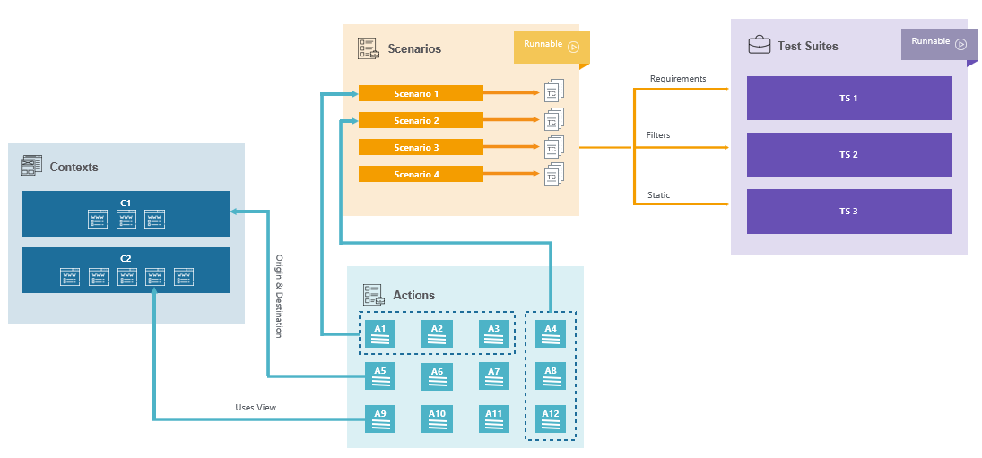](https://support.accelq.com/hc/article_attachments/360026079331/mceclip0.png)

Fig 2.8.1 Entities

#### ****Context****

Context is like a page in the application-under-test. Every distinct page in the application becomes a Context in accelQ. Context refers to a 'state' of the application-under-test (AUT), where a set of user actions are possible. In a typical web application, you can consider each distinct page of the application to be a Context. Examples include Home Page, Purchase Page etc. Context manages the Views (like screenshots of your application) and Elements relevant for your test logic.

#### ****Action****

Action is a meaningful functionality that a user can perform in one given page (context). Action includes logic to interact with browser or perform validations. Examples: Search for Flights, Navigate to Home Page, Verify Purchase Order etc. Action belongs to a Context and makes use of element from the Context's repository.

#### ****Scenario****

Scenario represents a use case or a test script on your application. It includes multiple steps going across different pages of your application. Each step in the Scenario is an Action from one of the pages in the application. Scenario represents a use case on the test application (AUT), which can be “run” as a test. A Scenario may yield multiple test cases, with each test case representing one set of data inputs required to perform the steps in the Scenario.

#### ****Test Case****

Test Case is an iteration of a Scenario that comprises the data to be used for that iteration. Each Scenario may have multiple test cases with different combinations of test data. When you run a Scenario which has multiple test cases, this same Scenario is repeatedly executed, once per each test case. It is similar to the typical data driven testing concept in testing.

#### ****Test Suite****

Test Suite is a collection of Scenarios grouped together for execution. A suite can be created either based on metadata filters (custom fields), User Stories or as a static set of Scenarios. You typically manage the execution requirement in a Sprint or a Release through a Suite.

**2.9 SWITCHING BETWEEN ASSIGNED ACCELQ PROJECTS**

A user can be assigned one or more ACCELQ Projects. By default, when a user logs in, the last used Project is opened. You can switch to a different Project by following steps below:

Click on the Project name item in the top-nav of the application.

[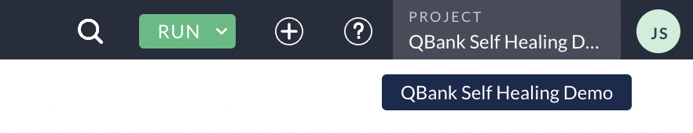](https://support.accelq.com/hc/article_attachments/6699367632269/mceclip0.png)

All your assigned Projects are listed at the bottom portion. Search or select the desired project in the list and switch to the Project.

[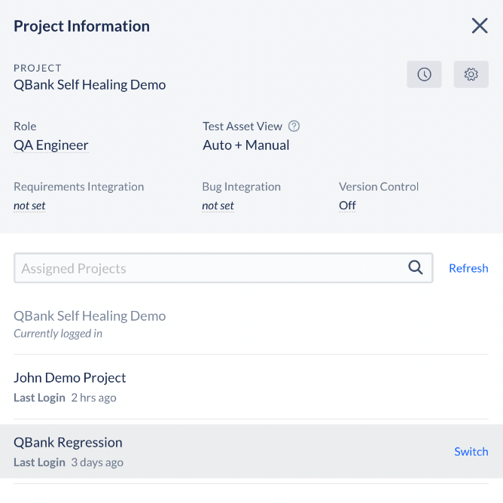](https://support.accelq.com/hc/article_attachments/6699379046157/mceclip2.png)

Fig 2.9.1 Project Information

### 2.10 TRACKING USER ACTIVITY AND ENTITY CHANGE HISTORY

User activity in accelQ can be tracked at a global level as well as an individual test asset level.

**Global user activity** can be accessed from the top toolbar icon. This activity tracks the creation, deletion and updates of entities without specifically identifying the type of update. You can also filter the activity based on a particular user.

[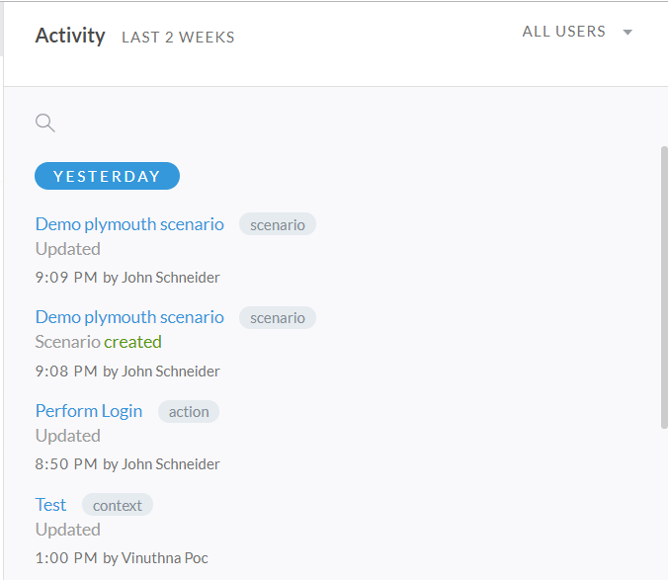](https://support.accelq.com/hc/article_attachments/360012895472/mceclip0.png)

Fig 2.10.1 Activity

**Entity level history** or activity can be tracked by clicking "view history" link in the side bar of corresponding entity such as an action or context. History is tracked at a granular level indicating the nature of updates.

### 2.11 SELECTING TEST ASSET VIEW

ACCELQ supports both manual and automated testing under one platform. Both these test assets are managed side by side bringing the unification and fluidity that is extremely important in an agile environment.

When you are assigned a Unified subscription, you may choose to select a Test Asset View for each project depending on what your main focus area is. If for a particular project, you are primarily functioning in manual testing mode, you can setup a Manual View. Similarly, you can setup an Automation only View.

To change your current Test Asset View, click on the badge displayed in the lower left corner of the screen that reads the name of current view.

|  |  |
| --- | --- |
|  |  |

Fig 2.11.1 Selecting test asset view

In the resulting popover, select desired view. This will become your default view every time you login to this project and each project may have a different View preference.

When you are working in Manual View, all the automation specific entities are hidden in the project. Similarly, when operating in the Automation View, manual assets are hidden. When you are working in Unified View, explicit marking is displayed differentiating Manual and Automation assets.

|  |  |
| --- | --- |
|  |  |

### 3.OBSERVATION

In accelq I have worked on the exercises related to automation testing problems with the help of accelq platform. Without writing code or anything, simply I have done testing. I can say that it is reduced my time when I started testing compared to the manual verifying. The web elements, input fields , search bars in web page are verified on accelq platform. If any test case fails it shows where the error occurred and also we have a screenshot feature in the accelq platform. It captures the every event in the flow of automation. By that we can identify the error easily and solve it.

### Example Exercise:

### 

### Implementation:

### 

### Screenshot 3.1 Test Steps

In screenshot 3.1 the steps that are created to achieve the given task. The steps contains all the operations that we are going to perform on the test case. In the above screenshot firstly, browser is invoked by the agent running on background. When the mentioned site is opened it verifies all the departments and all the menu items which are present on the website.

### 

### Screenshot 3.2 verifying all menu items

In screenshot 3.2 the code which is written is going to verify the menu items which are presented on the website. It checks the line by line if any item not found it results the test case failure else test case pass.

### 

### Screenshot 3.3 data list

### 

A data list refers to a collection of data types that alloes a single entity to store multiple variables. For example, consider a Table or a Database that must store different types of values . Data lists can store all the values in the same field. Screenshot 3.3 showing the code that is used to create data list.

### 

### Screenshot 3.4 verify department

In screenshot 3.2 the code which is written is going to verify the departments which are presented on the website. It checks the line by line if any item not found it results the test case failure else test case pass.

### 4. LEARNING AFTER INTERNSHIP

I have learnt how to work with the accelq platform with the help of the mentors of the accelq. Really it was very fun in testing the websites with low code or no code. I have done exercises given by the accelq mentors. They clarified every doubts related to accelq platform and guided me how to achieve the given task. I have worked with the accelq platform and accelq agent . I am tested the websites with the help of accelq platform. I have verified the web elements and input fields, is it properly performing their tasks or not? Any errors encountered it is easy through accelq platform. Handling errors and problems in web page using accelq software.

### CONCLUSION

Accelq is very helpful, time saving and manpower reducing automation testing platform. It reduces the effort and make the testing easy with the user friendly software environment. Interaction with the platform is very easy. It has the ability to handle the big data. It is no code, low code platform. In feature the Accelq is going to play a major role in testing. It is go on a work based on the requirements.

### 6.BIBLIOGRAPHY

### Learning sites:

### 1.Accelq Articles [ www.accelq.com ]

### 2.Excercise videos by Accelq